Experiment No: 1

Q.Create html pages for website like login, registration and about us pages.

Program:

1.1 login page

<!DOCTYPE html>

<html lang="en">

<head>

<meta charset="UTF-8" />

<title>Enhanced Login Form</title>

</head>

<body>

<h2>Login to Your Account</h2

<form action="/login" method="post">

<label for="username">Username</label><br>

<input type="text" id="username" name="username" placeholder="Enter your username" required autofocus

/><br><br>

<label for="password">Password</label><br>

<input type="password" id="password" name="password" placeholder="Enter your password" required

/><br><br>

<label>

<input type="checkbox" name="remember" />

Remember me

</label><br><br>

<input type="submit" value="Login" /><br><br>

<a href="#">Forgot your password?</a>

</form>

</body>

</html>

**Output:**

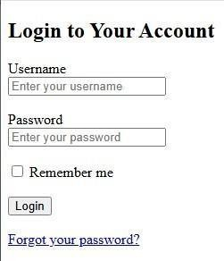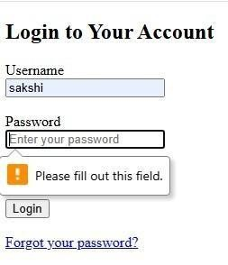

Experiment No:5

Q.Create a simple Testing Angular Application.

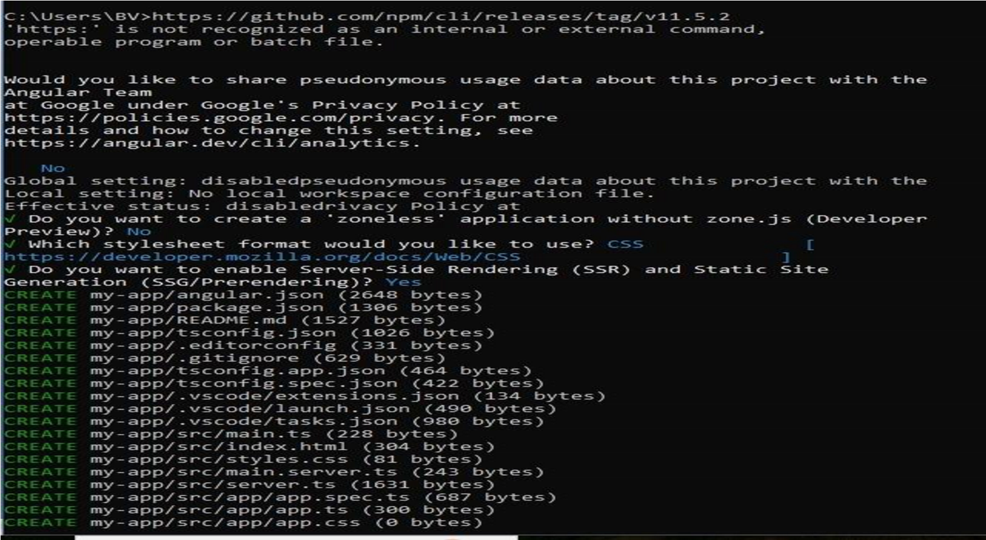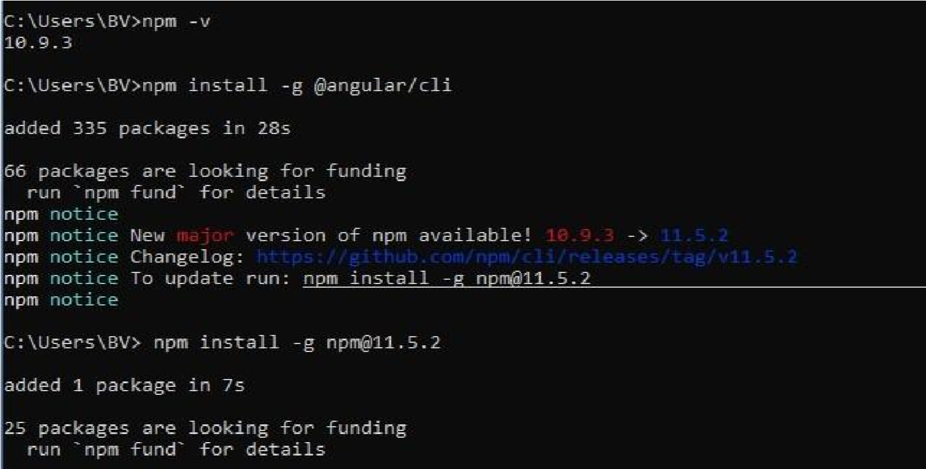

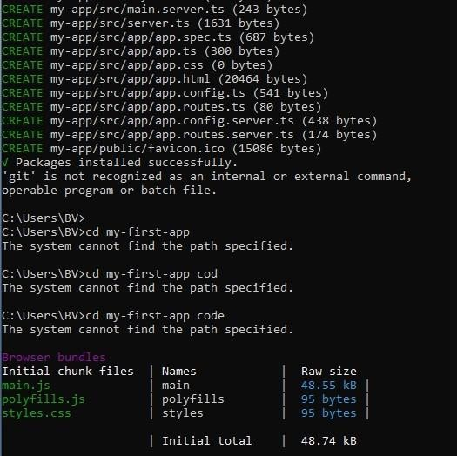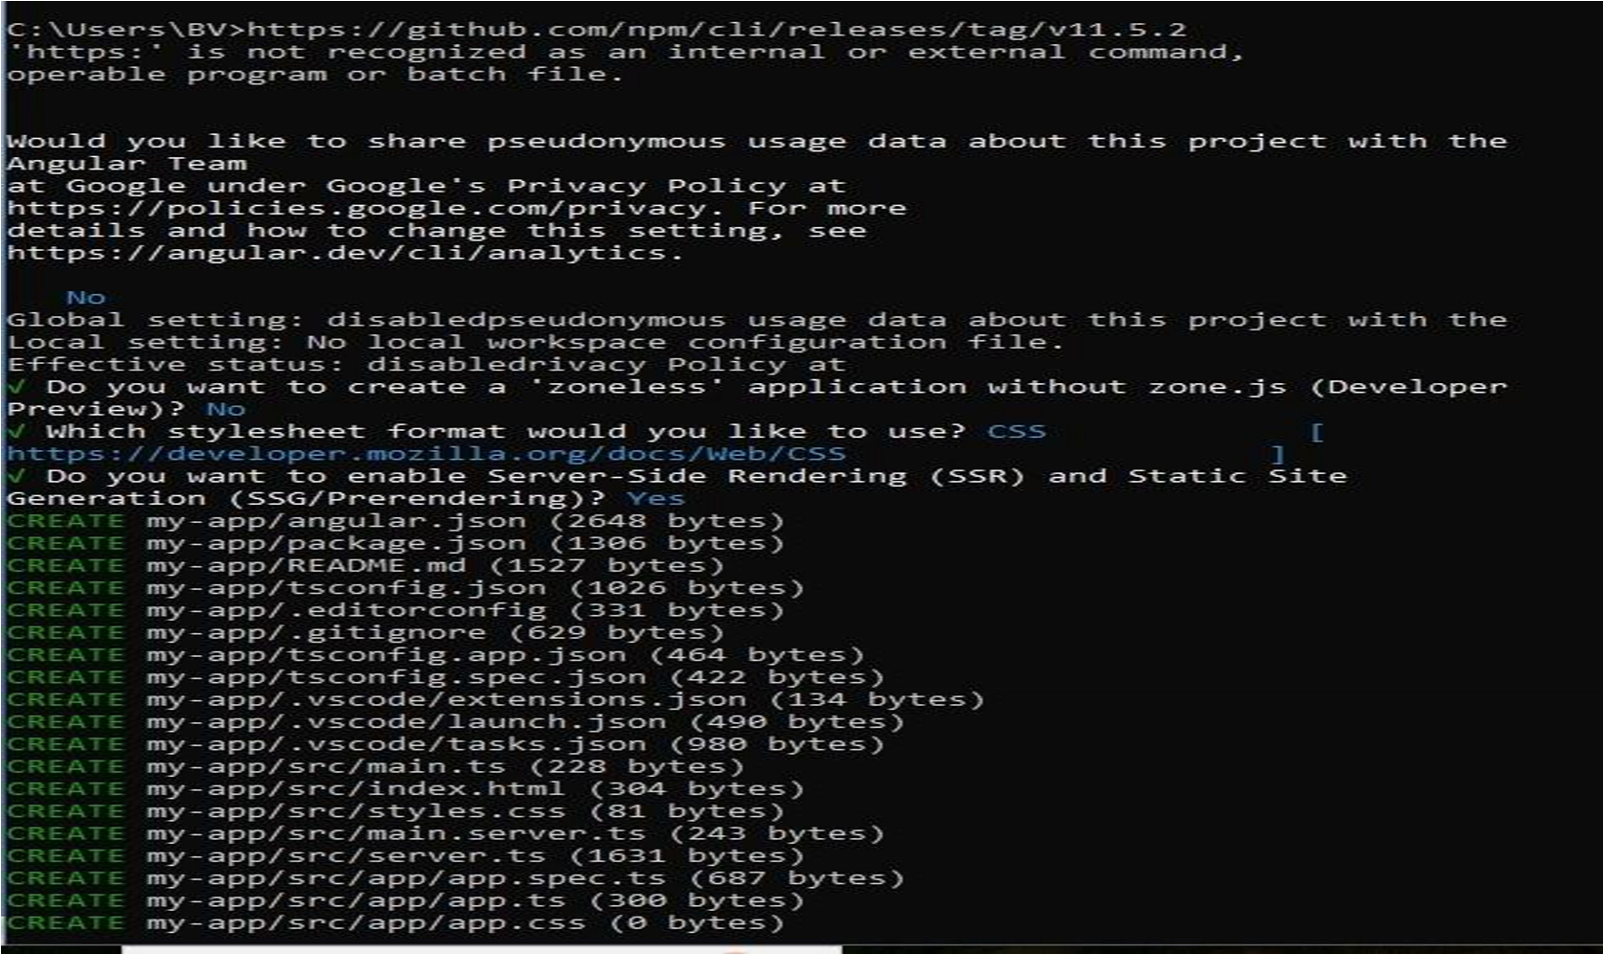



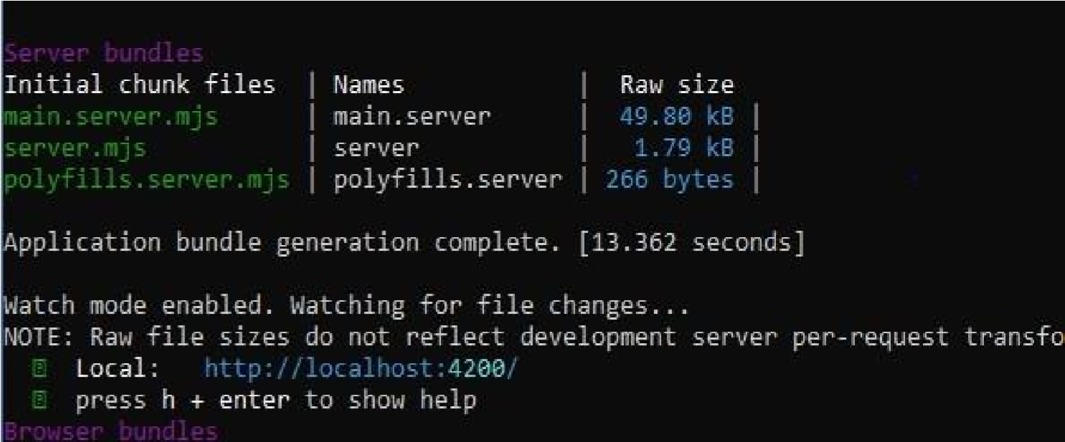

//HTML Code

<!DOCTYPE html>

<html lang="en">

<head>

<meta charset="UTF-8">

<meta name="viewport" content="width=device-width, initial-scale=1.0">

<title>Document</title>

</head>

<body>

<h1>My First Angular Application</h1>

</body>

</html>



**Experiment No:6**

Q.Write a program demonstrating node.js application.

const num1=5; const num2=3; const sum=num1+num2;

console.log('The sum of '+num1+' and '+num2+' is:' +sum);

Output:

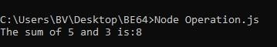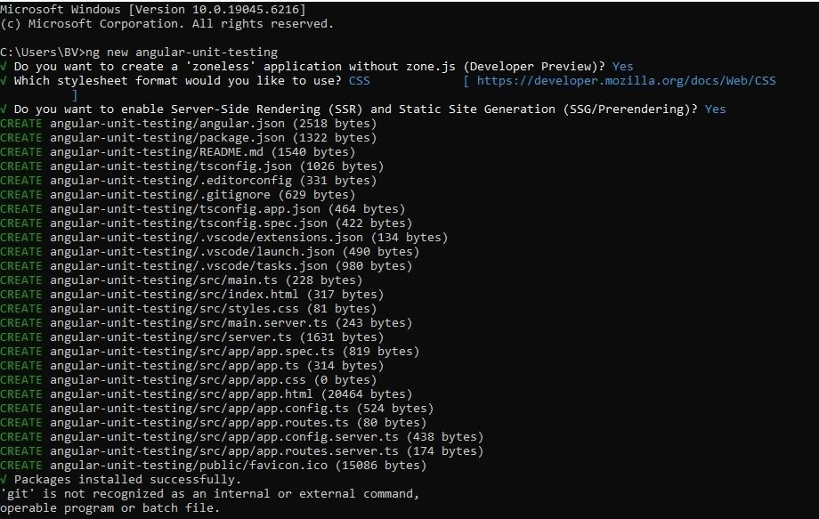

**Experiment No:3**

Q. Write a program to demonstrate javascript functions and different validations.

Program:

<!DOCTYPE html>

<html lang="en">

<head>

<meta charset="UTF-8">

<title>Registration Form</title>

<style>

body {

font-family: Arial, sansserif; background: #e0f2f1; display: flex; justify-content: center;

alignitems: center; height: 100vh; margin: 0;

}

form { background: #fff; padding: 30px 40px; border-radius: 10px; box-shadow: 0 8px 20px rgba(0, 0, 0, 0.1);

width: 100%; max-width: 500px;

}

h2 { text-align: center; color: #333;margin-bottom: 25px; }

label { display: block; margin-bottom: 6px; fontweight: bold; }

input[type="text"], input[type="password"], input[type="email"], input[type="number"]

{ width: 100%; padding: 10px; marginbottom: 12px; border: 1px solid #ccc; border-radius: 5px; fontsize: 15px; }

.gender-group { margin-bottom: 15px; }

.gender-group label { font-weight: normal; margin-right: 15px; }

.terms { margin-bottom: 15px; }

input[type="submit"] { background-color: #4CAF50; color: white; padding: 12px; width: 100%;

border: none; borderradius: 5px; font-size: 16px; cursor: pointer; }

input[type="submit"]:hover { background-color: #45a049; }

.error { color: red; fontsize: 14px; margin-top: -10px; margin-bottom: 10px; }

</style>

</head>

<body>

<form id="registrationForm" onsubmit="return validateForm()">

<h2>Registration Form</h2>

<label for="firstname">First Name:</label>

<input type="text" id="firstname" name="firstname">

<div class="error" id="firstnameError"></div>

<label for="lastname">Last Name:</label>

<input type="text" id="lastname" name="lastname">

<div class="error" id="lastnameError"></div>

<label for="email">Email:</label>

<input type="email" id="email" name="email">

<div class="error" id="emailError"></div>

<label for="password">Password:</label>

<input type="password" id="password" name="password">

<div class="error" id="passwordError"></div>

<label for="confirmPassword">Confirm Password:</label>

<input type="password" id="confirmPassword" name="confirmPassword">

<div class="error" id="confirmPasswordError"></div>

<label for="age">Age:</label>

<input type="number" id="age" name="age" min="1">

<div class="error" id="ageError"></div>

<label>Gender:</label>

<div class="gender-group">

<label><input type="radio" name="gender" value="male"> Male</label> <label><input type="radio" name="gender" value="female"> Female</label>

<label><input type="radio" name="gender" value="other"> Other</label>

</div>

<div class="error" id="genderError"></div>

<div class="terms">

<label><input type="checkbox" id="terms"> I accept all terms and conditions.</label> </div>

<div class="error" id="termsError"></div>

<input type="submit" value="Register">

</form> <script> function validateForm() { let isValid = true; //

Clear errors document.querySelectorAll('.error').forEach(el => el.innerText

= '');

// Form values

const firstname = document.getElementById('firstname').value.trim();

const lastname = document.getElementById('lastname').value.trim();

const email = document.getElementById('email').value.trim();

const password = document.getElementById('password').value;

const confirmPassword = document.getElementById('confirmPassword').value;

const age = document.getElementById('age').value;

const genderChecked = document.querySelector('input[name="gender"]:checked');

const termsChecked = document.getElementById('terms').checked;

// Validations

if (firstname === '') {

document.getElementById('firstnameError').innerText = 'First name is required.';

isValid = false;

} if (lastname === '') {

document.getElementById('last nameError').innerText = 'Last name is required.';

isValid = false;

} if (email === '') {

document.getElementById('emailError').innerText = 'Email is required.';

isValid = false;

} else if (!/^[^\s@]+@[^\s@]+\.[^\s@]+$/.test(email)) {

document.getElementById('emailError').innerText = 'Invalid email format.';

isValid = false;

} if (password.length < 6) {

document.getElementById('passwordError').innerText = 'Password must be at least 6 characters.'; isValid = false;

}

if (confirmPassword !== password) {

document.getElementById('confirmPasswordError').innerText = 'Passwords do not match.';

isValid = false;

} if (age === '' || isNaN(age) || Number(age) <= 0) {

document.getElementById('ageError').innerText = 'Please enter a valid age.';

isValid = false;

} if (!genderChecked) {

document.getElementById('genderError').innerText = 'Please select your gender.';

isValid = false;

} if (!termsChecked) {

document.getElementById('termsError').innerText = 'You must accept the terms and conditions.';

isValid = false;

} return isValid; }

</script>

</body>

</html>

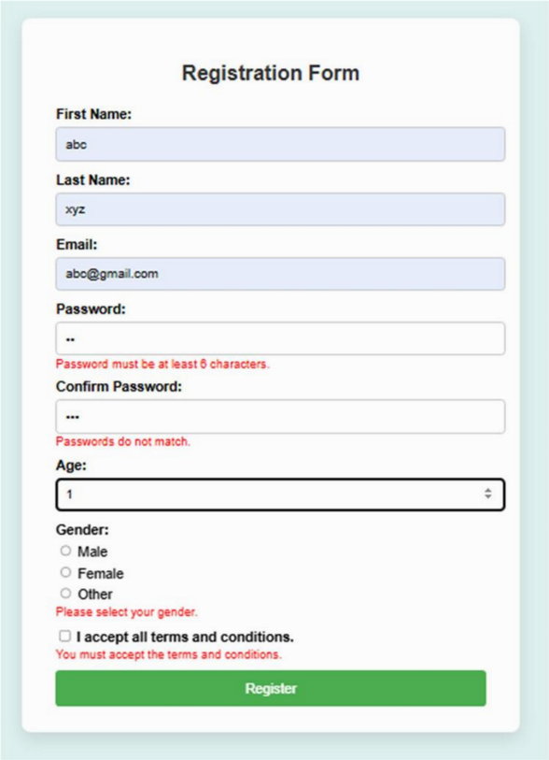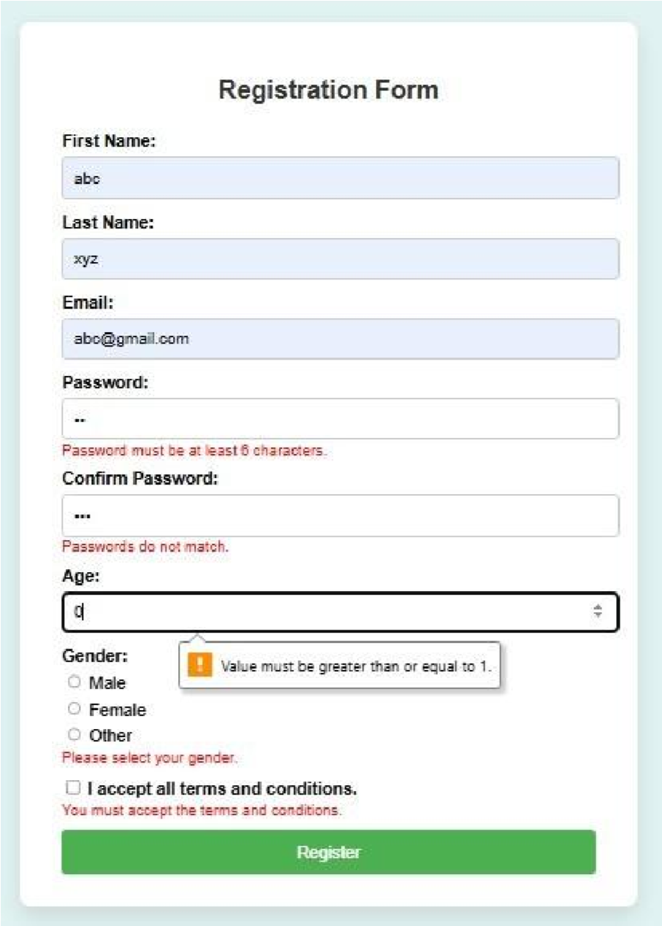 **Output:**

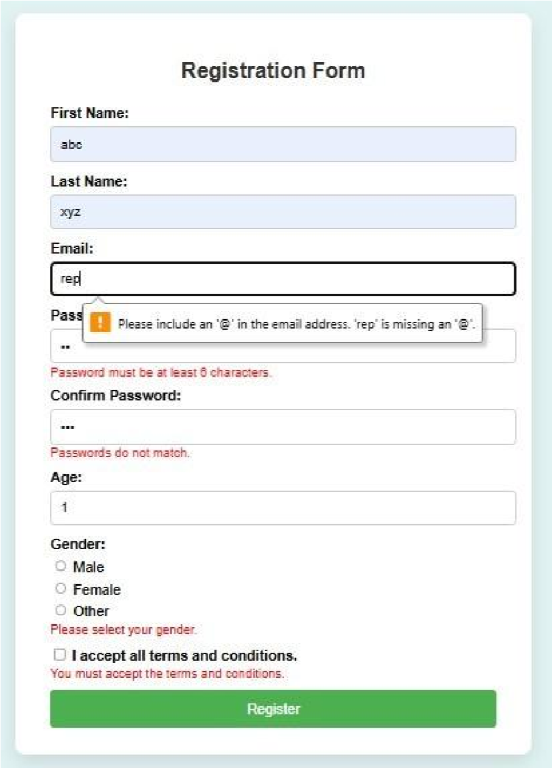

**Experiment No:2**

**Q.Design a web page using css: apply css to pages crated in first experiment.**

**Program:**

<!DOCTYPE html>

<html lang="en">

<head>

<meta charset="UTF-8" />

<meta name="viewport" content="width=device-width, initial-scale=1.0"/>

<title>Registration Form</title>

<style>

/* Background */

body { margin: 0; padding: 0; font-family: 'Segoe UI', Tahoma, Geneva, Verdana, sans-serif; background: linear-gradient(135deg, #b7e4c7 0%, #95d5b2 100%);

display: flex; justify-content: center; align-items: flex-start; min-height: 100vh;

}

/* Outer title */

.page-title { width: 100%; text-align: center; margin-top: 40px; margin-bottom: 20px; font-size: 32px; font-weight: bold; color: #2d6a4f;

}

/* Container */

.container { background: white; padding: 40px; border-radius: 10px; box-shadow: 0 10px 30px rgba(0,0,0,0.1); width: 100%; max-width: 500px; margin-bottom: 40px; }

h2 { text-align: center; color: #2d6a4f; margin-bottom: 30px; }

label { display: block; margin-bottom: 6px; color: #333; font-weight: 500; font-size: 14px;}

input[type="text"], input[type="email"], input[type="password"], input[type="date"] {

width: 100%; padding: 10px 12px; margin-bottom: 20px; border: 1px solid #ccc; border-radius: 5px; font-size: 15px; transition: border 0.3s ease, box-shadow 0.3s ease; }

input:focus { border-color: #52b788; box-shadow: 0 0 5px rgba(82, 183, 136, 0.4); outline: none; }

.gender-options { margin-bottom: 20px;

}

.gender-options label { display: inline-block; margin-right: 15px; font-weight: normal; font-size: 14px;}

.terms { margin-bottom: 20px; font-size: 13px; }

input[type="submit"] { background-color: #52b788; color: white; padding: 12px;

width: 100%; border: none; border-radius: 5px; font-size: 16px; font-weight: bold; cursor: pointer; transition: background-color 0.3s ease;

}

input[type="submit"]:hover { background-color: #40916c;

} .footer { text-align: center; margin-top: 20px; font-size: 14px; color: #555;

}

.footer a { color: #40916c; text-decoration: none;

}

.footer a:hover { text-decoration: underline;

}

</style>

</head>

<body>

<div class="container">

<h2>Registration Form</h2>

<form action="/submit" method="post"> <label for="firstname">First Name</label>

<input type="text" id="firstname" name="firstname" required />

<label for="lastname">Last Name</label>

<input type="text" id="lastname" name="lastname" required />

<label for="email">Email Address</label>

<input type="email" id="email" name="email" required />

<label for="password">Password</label>

<input type="password" id="password" name="password" required />

<label for="confirm-password">Confirm Password</label>

<input type="password" id="confirm-password" name="confirm_password" required />

<label>Gender</label>

<div class="gender-options">

<label><input type="radio" name="gender" value="male" required /> Male</label>

<label><input type="radio" name="gender" value="female" /> Female</label>

<label><input type="radio" name="gender" value="other" /> Other</label> </div>

<label for="dob">Date of Birth</label>

<input type="date" id="dob" name="dob" required />

<div class="terms">

<label>

<input type="checkbox" name="terms" required />

I accept the <a href="#">terms and conditions</a>.

</label>

</div>

<input type="submit" value="Register" />

</form>

<div class="footer">

Already have an account? <a href="/login">Login here</a>

</div>

</div>

</body>

</html>

**Output:**

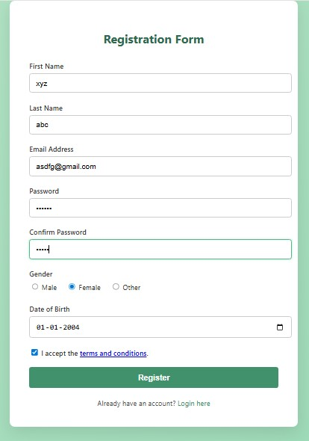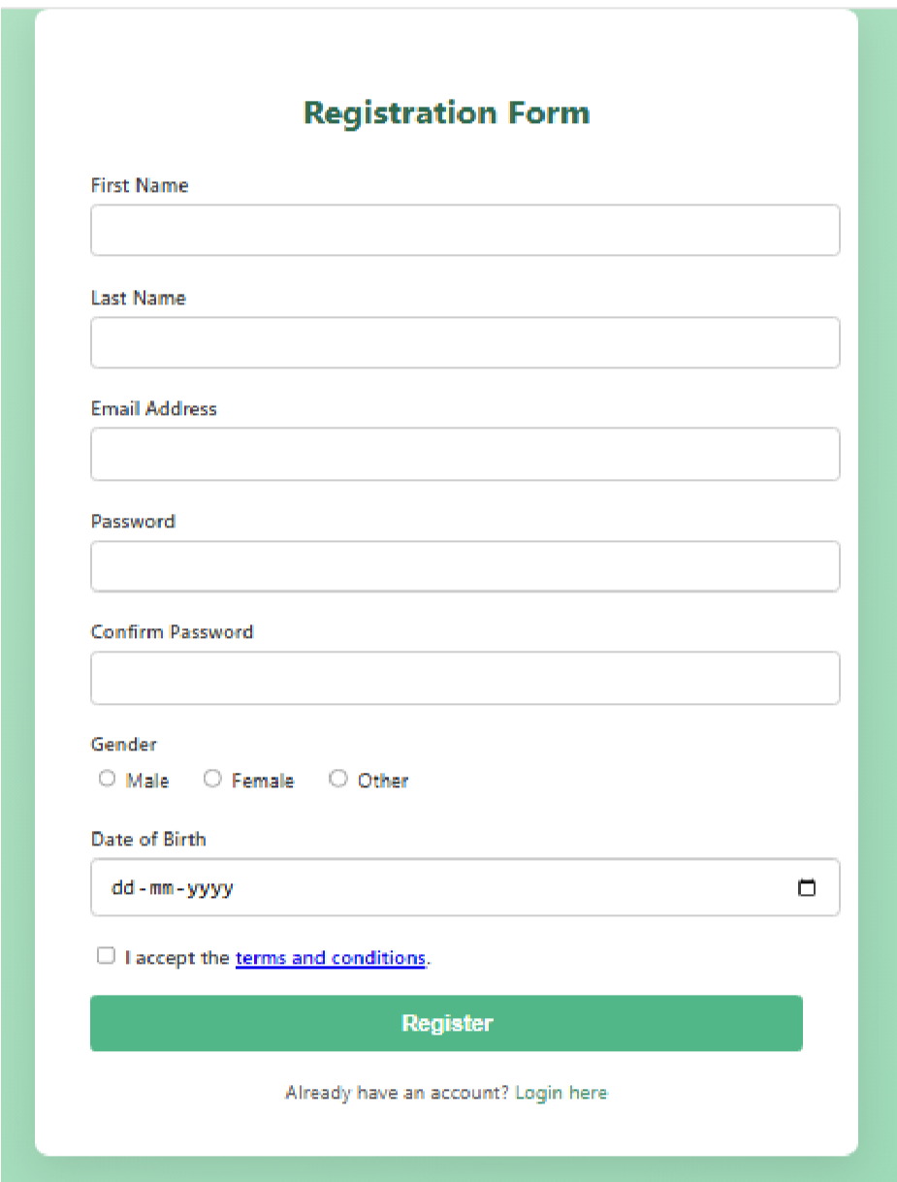

**Experiment No:4**

**Q. Write a program to read and write Html contents with JQuery.**

**Program:**

<!DOCTYPE html>

<html>

<head>

<title>Read and Write HTML with jQuery</title>

<script src="https://code.jquery.com/jquery-3.6.0.min.js"></script>

</head>

<body>

<h2 id="heading">Welcome to my page</h2>

<div id="content">

<p>This is some <b>original</b> content.</p>

</div>

<input type="text" id="inputtext" placeholder="Enter new content here">

<br><br>

<button id="readBtn">Read Content</button>

<button id="writeBtn">Write Content</button>

<p id="output"></p>

<script>

$(document).ready(function() { $("#readBtn").click(function() { let htmlData = $("#content").html(); let textData = $("#content").text();

$("#output").html("<b>HTML:</b> " + htmlData + "<br><br><b>Text:</b> " + textData);

});

$("#writeBtn").click(function() { let newContent = $("#inputtext").val();

$("#content").html(newContent);

$("#output").html("<i>Content updated</i>");

});

});

</script>

</body>

</html>

**Output:**

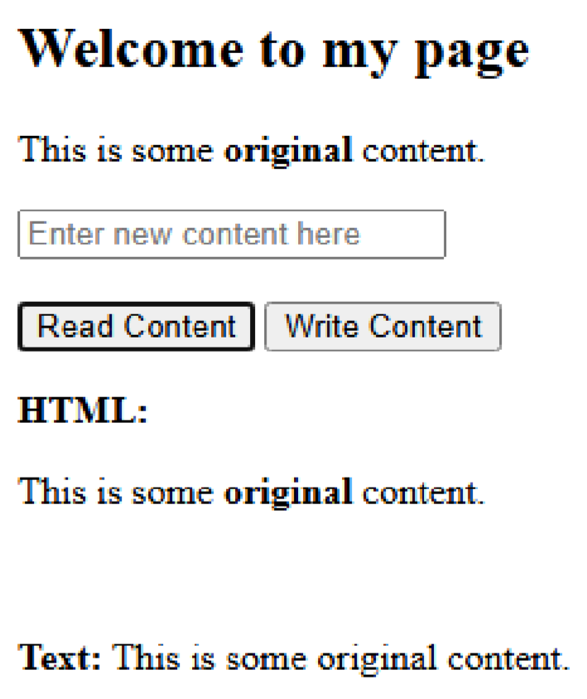

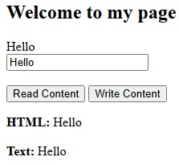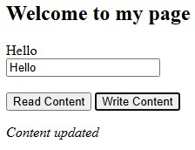

Experiment No. 7

Q. Write a program to handle the error in Nodejs.

Program:

try { const num I 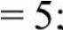const num2 = 'a';

// invalid number

if (typeofnuml !== 'number' I l typeofnum2 !== 'number')

{

throw new Error('lnputs must be numbers');

console.log(numl + num2);

}

catch (err) {

console.error('Error:', err.message); }

Output:

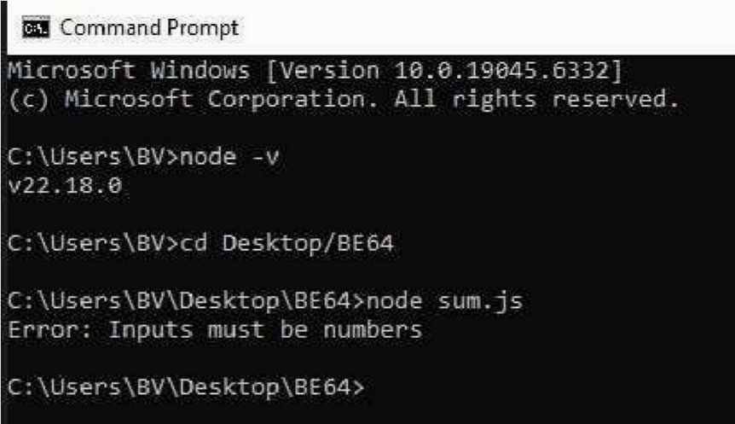

**Experiment No : 8**

**Q. Installation of XAMPP.**

 

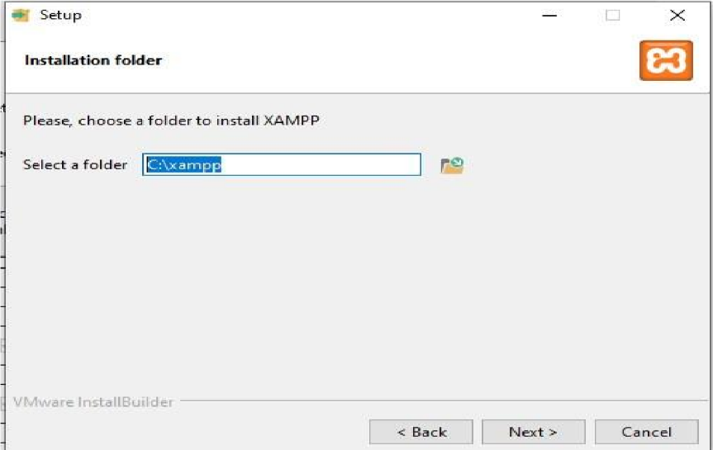

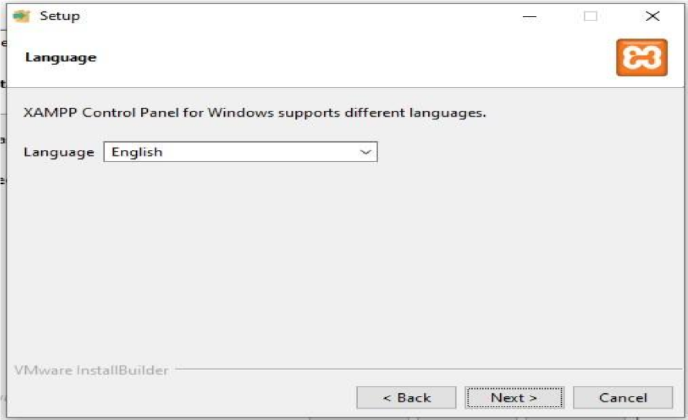





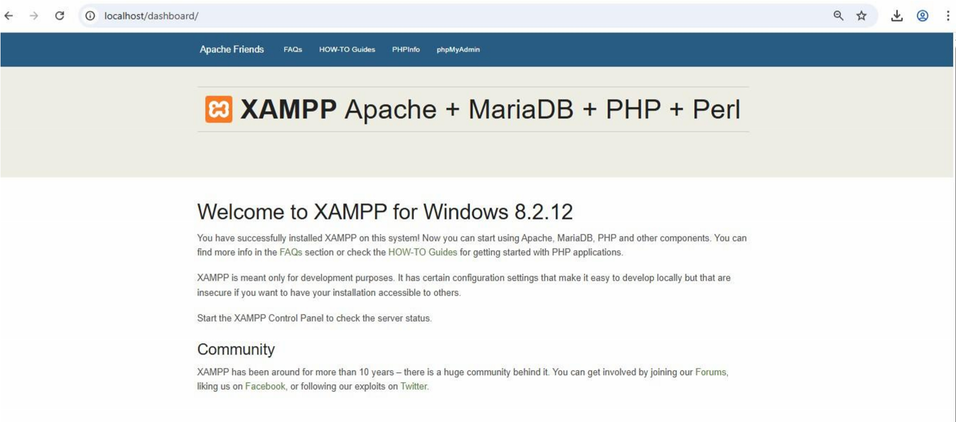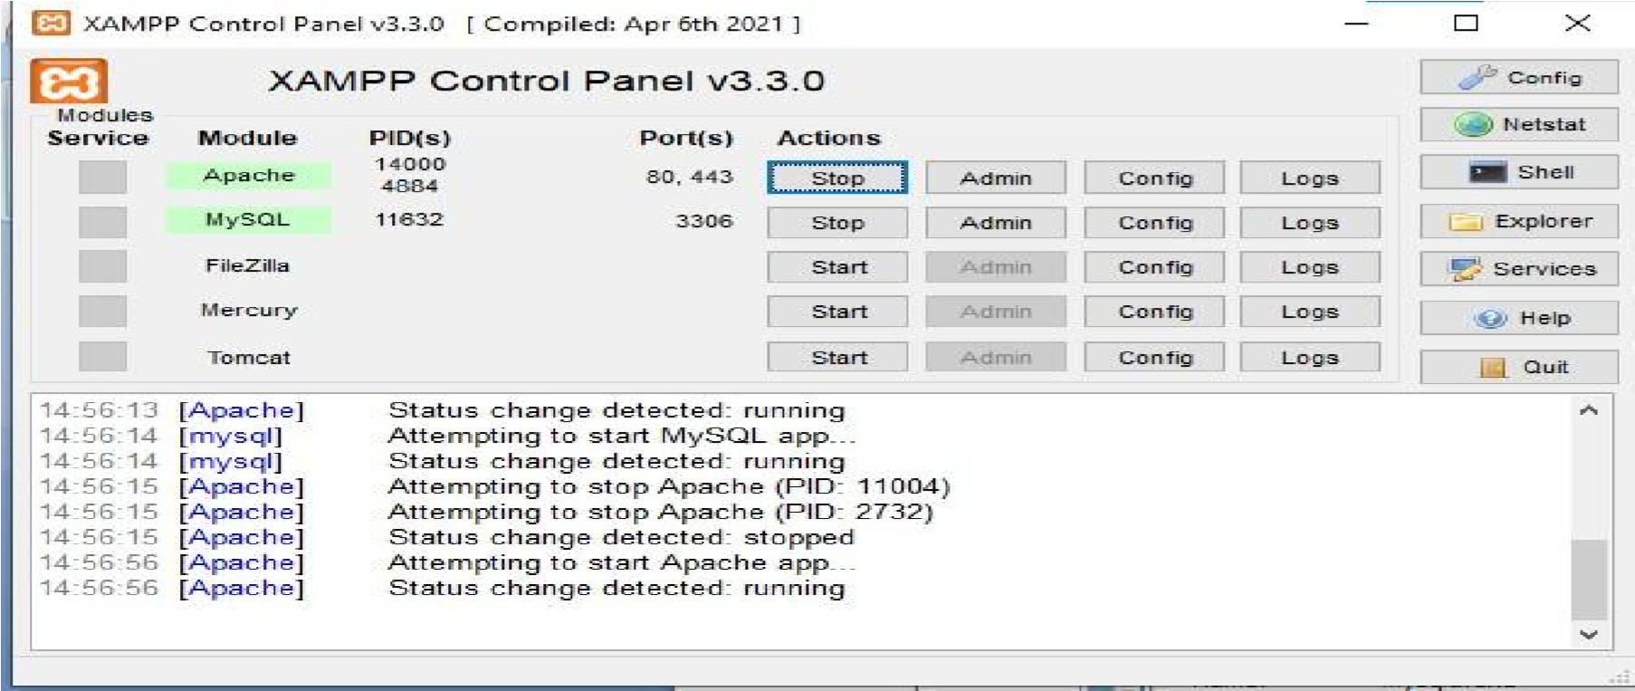**Experiment No:9**

Q. Program based on PHP variables, expressions ,array and control structures.

<?php

**//1.Variables**

$name="Daisy";

$Age=22;

$score=92;

**//2.Expression**

$passed=($score>=50);

**//3.Array**

$subjects=array("Maths"=>90,"English"=>85,"Science"=>78); echo"Student Name:$name\n"; echo"Age:$Age\n";

**//4.Control Structure**

if/else if($passed){ echo"Status:Passed\n";

} else{ echo"Status:Failed\n";}

**//4.Control Structure-FOREACH**

echo"\nSubject

Scores:\n";

$total=0; foreach($subjects as $subject=>$marks){

echo"$subject:$marks\n";

$total+=$marks; }

**//4.Control Structure-FOR**

$average=$total/count($subjects); echo"\nAverage

Score:$average\n";

**//Nested if**

if($average>=90){ echo"Grade:A\n";

}

elseif($average>=75){ echo

"Grade:B\n";

}elseif($average>=60){ echo

"Grade:C\n"; }

else{ echo"Grade:D\n";

}

?>

Output:

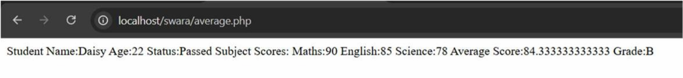

# Experiment No:10

Q. Experiment based on OOP and advance OOP in PHP.

//Single Inheritance

<?php class Animal { public func on eat() { echo "This animal eats food.\n";

}

}

class Dog extends Animal { public func on bark() { echo "The dog barks loudly.\n";

}

}

$dog = new Dog();

$dog->eat(); // Inherited method

$dog->bark(); // Child class method

?>

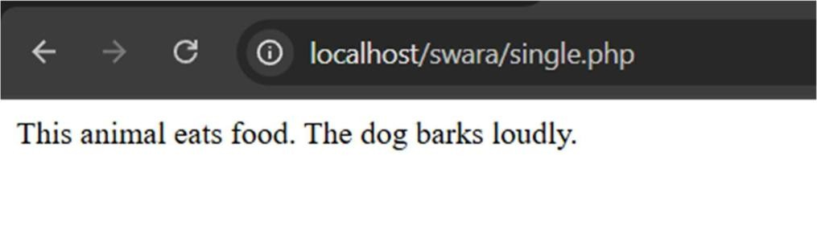

//Multiple Inheritance

<?php

trait Trait1 { public func on showA() { echo "This is from Trait 1.\n";

} } trait Trait2 {

public func on showB() { echo

"This is from Trait 2.\n";

}

}

class MyClass { use Trait1, Trait2; public func on showC() { echo "This is from MyClass.\n";

}

}

$obj = new MyClass();

$obj->showA();

$obj->showB();

$obj->showC();

?>

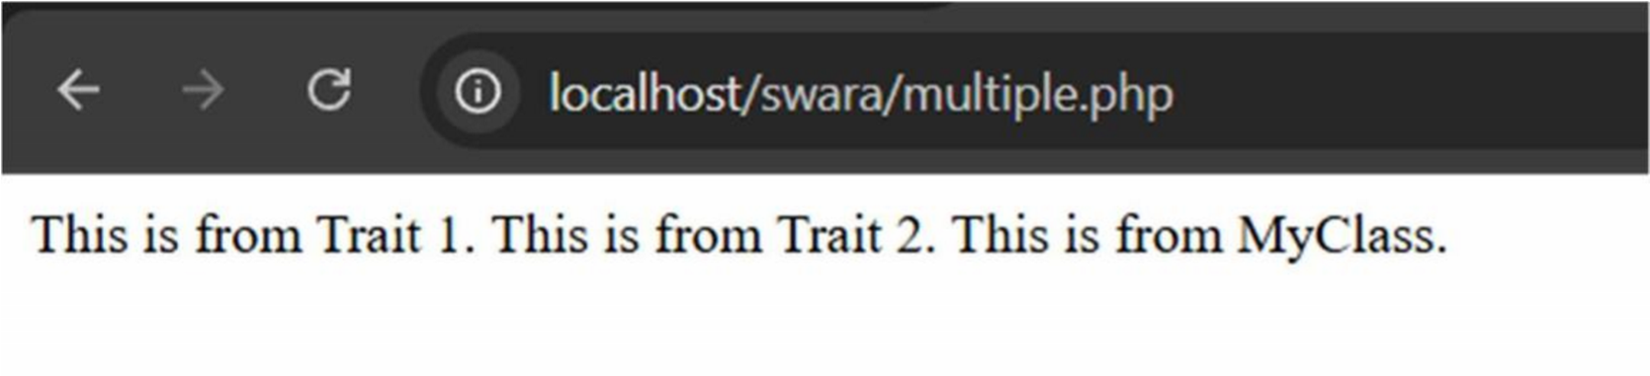

//Mul level Inheritance

<?php class GrandParentClass { public func on showGrandParent() { echo "This is the Grandparent class.\n";

}

}

class ParentClass extends GrandParentClass { public func on showParent() { echo "This is the Parent class.\n";

}

}

class ChildClass extends ParentClass { public func on showChild() { echo

"This is the Child class.\n";

}

}

$obj = new ChildClass();

$obj->showGrandParent();

$obj->showParent();

$obj->showChild();

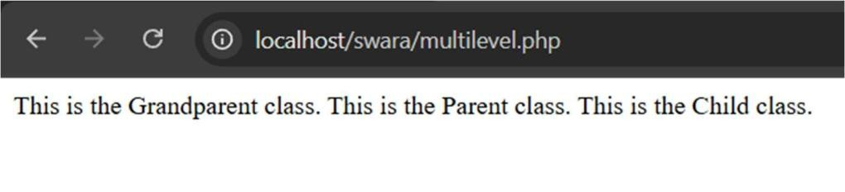?>

Experiment No:11

Q. Form Validate on using PHP using regular expression.

<!DOCTYPE html>

<html>

<head>

< tle>Form Valida on using PHP (Regex)</ tle>

</head>

<body>

<?php

$nameErr = $emailErr = $passwordErr = ""; $name = $email = $password = ""; if ($_SERVER["REQUEST_METHOD"] == "POST") {

if (empty($_POST["name"])) {

$nameErr = "Name is required";

} else {

$name = $_POST["name"]; if

(!preg_match("/^[a-zA-Z ]*$/", $name)) {

$nameErr = "Only le ers and spaces are allowed";

}

}

if (empty($_POST["email"])) {

$emailErr = "Email is required";

} else {

$email = $_POST["email"]; if (!preg_match("/^[a-zA-Z0-9._%+-]+@[a-zA- Z0-9.-]+\.[a-z]{2,}$/", $email)) { $emailErr = "Invalid email format";

}

}

if (empty($_POST["password"])) {

$passwordErr = "Password is required";

} else {

$password = $_POST["password"];

if (!preg_match("/^(?=.*[A-Z])(?=.*[a-z])(?=.*\d)(?=.*[@$!%*?&])[A-Za-z\d@$!%*?&]{8,}$/", $password)) {

$passwordErr = "Password must be at least 8 characters, include an uppercase, lowercase, number and special character";

}

}

}

?>

<h2>PHP Form Valida on using Regular Expressions</h2>

<form method="post" ac on="<?php echo htmlspecialchars($_SERVER["PHP_SELF"]);?>">

Name: <input type="text" name="name" value="<?php echo $name;?>">

<span style="color:red;">* <?php echo $nameErr;?></span>

<br><br>

Email: <input type="text" name="email" value="<?php echo $email;?>">

<span style="color:red;">* <?php echo $emailErr;?></span>

<br><br>

Password: <input type="password" name="password">

<span style="color:red;">* <?php echo $passwordErr;?></span>

<br><br>

<input type="submit" value="Submit">

</form> <?php

if ($nameErr == "" && $emailErr == "" && $passwordErr == "" && $_SERVER["REQUEST_METHOD"]

== "POST") { echo "<h3 style='color:green;'>Form submi ed successfully!</h3>"; echo "Name: $name <br>"; echo "Email: $email <br>";

}

?>

</body>

</html>

Output:

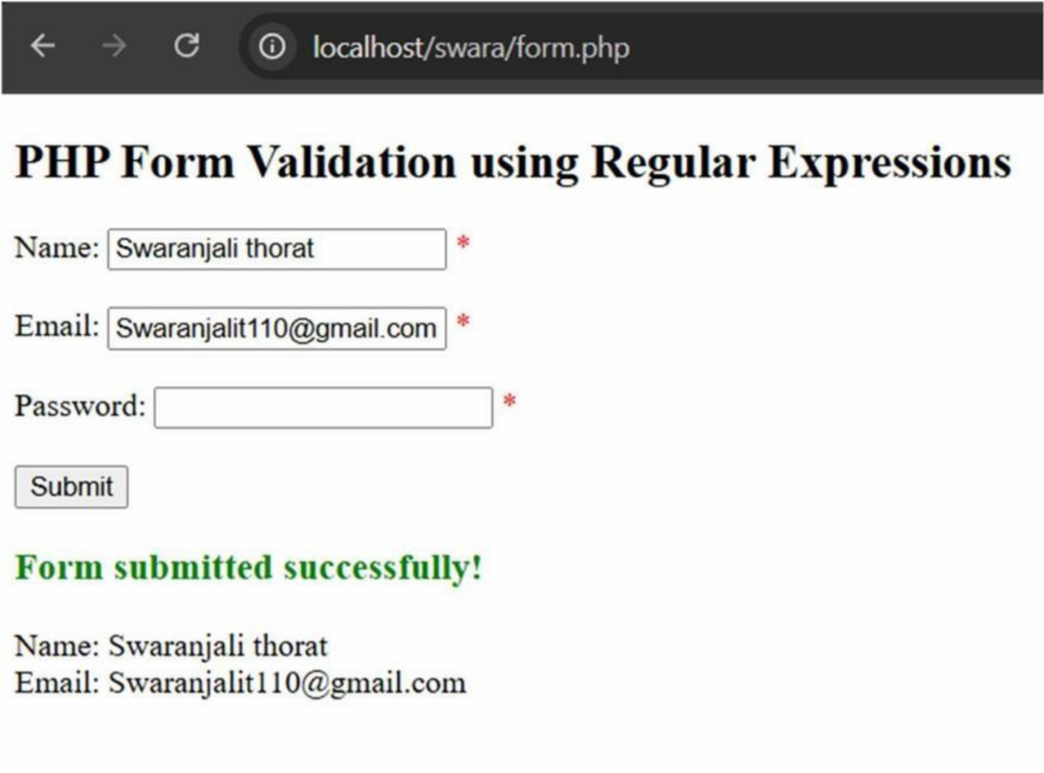

Experiment No:12

Q. Upload various types of file from Client side to server with valida on.

<!DOCTYPE html>

<html>

<head>

< tle>File Upload with Valida on</ tle>

</head>

<body>

<h2>Upload File</h2>

<form ac on="upload.php" method="POST" enctype="mul part/form-data">

<label>Select a file:</label>

<input type="file" name="myfile" required>

<br><br>

<input type="submit" value="Upload File">

</form>

</body>

</html>

Output:

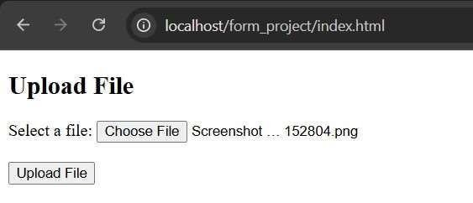

<?php

$targetDir = "uploads/"; if

(!is_dir($targetDir)) { mkdir($targetDir,

0777, true);

}

if (isset($_FILES['myfile'])) {

$fileName = $_FILES['myfile']['name'];

$fileTmp = $_FILES['myfile']['tmp_name'];

$fileSize = $_FILES['myfile']['size'];

$fileError = $_FILES['myfile']['error'];

$fileExt = strtolower(pathinfo($fileName, PATHINFO_EXTENSION));

$allowed = ['jpg', 'jpeg', 'png', 'gif', 'pdf', 'doc', 'docx', 'txt']; if

($fileError === 0) { if (in_array($fileExt, $allowed)) { if

($fileSize <= 5 * 1024 * 1024) { // 5 MB limit //

Step 7: Rename file to avoid duplicates

$newFileName = uniqid("file_", true) . '.' . $fileExt;

// Step 8: Upload file to folder $targetFile =

$targetDir . $newFileName; if

(move_uploaded_file($fileTmp, $targetFile)) { echo

"<h3> File uploaded successfully!</h3>"; echo

"Saved as: " . htmlspecialchars($newFileName);

} else {

echo "<h3> Error moving file.</h3>";

}

} else {

echo "<h3> File size must be less than 5 MB.</h3>";

}

} else {

echo "<h3> Invalid file type. Allowed: JPG, PNG, GIF, PDF, DOC, DOCX, TXT.</h3>";

}

} else {

echo "<h3> Upload error code: $fileError</h3>";

}

} else { echo "<h3> No file selected.</h3>";

}

?>

Output:

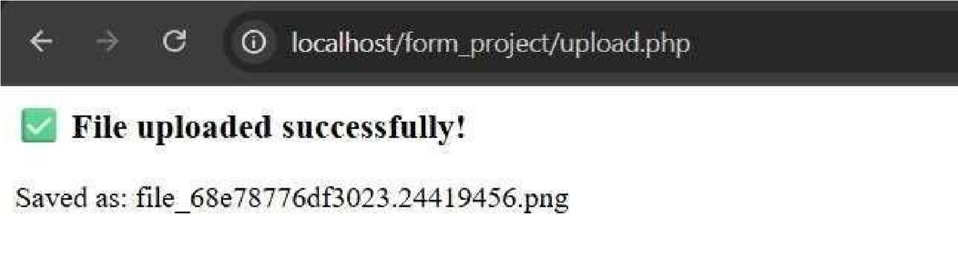

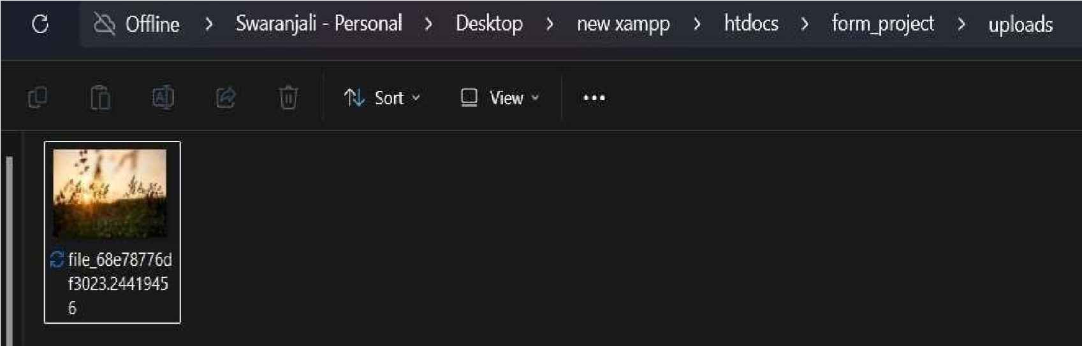

Experiment No:13

Q. Write a program to create and handle a session, cookie in PHP.

<?php session_start(); if (!isset($_SESSION["username"]))

{ $_SESSION["username"] = "Swaranjali"; echo

"Session created!<br>";

} else {

echo "Welcome back, " . $_SESSION["username"] . "!<br>";

}

$cookie_name = "user"; $cookie_value = "Thorat"; setcookie($cookie_name, $cookie_value, me() + 3600, "/"); if

(isset($_COOKIE[$cookie_name])) { echo "Cookie '" .

$cookie_name . "' is set!<br>"; echo "Value: " .

$_COOKIE[$cookie_name];

} else { echo "Cookie is not set yet.";

}

echo '<br><br><a href="?destroy_session=1">Destroy Session</a> |

<a href="?delete_cookie=1">Delete Cookie</a>';

if (isset($_GET['destroy_session'])) { session_destroy(); echo "<br>Session destroyed!";

}

if (isset($_GET['delete_cookie'])) { setcookie($cookie_name, "", me() - 3600, "/"); echo "<br>Cookie deleted!";

}

?>

Output:

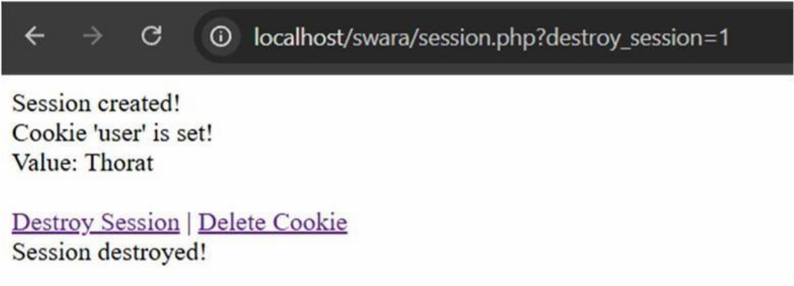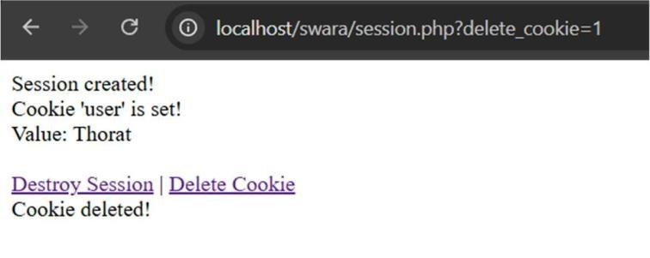

**Experiment No:14**

**Title** :- **Insert user entered data in form to MYSQL database using PHP**

// Index.html:-

<!DOCTYPE html>

<html lang="en">

<head>

    <meta charset="UTF-8">

    <meta name="viewport" content="width=device-width, initial-scale=1.0">

    <title>Data experiment</title>

</head>

<body>

    <h2>register user</h2>

    <form action="insert.php" method="post">

        <label for="">Name:</label><br>

        <input type="text" name="name"required> <br><br>

        <label for="">Email::</label><br>

        <input type="email" name="email"required> <br><br>

        <label for="">password:</label><br>

        <input type="password" name="password"required> <br><br>

        <input type="submit" value="submit">

    </form>

</body>

</html>

// Folder Insert.php

Code;

<?php

$servername = "localhost";

$username = "root";

$password = "";  // default for XAMPP

$database = "webtech_db";

$conn = new mysqli($servername, $username, $password, $database);

if ($conn->connect_error) {

    die("Connection failed: " . $conn->connect_error);

}

$name = $_POST['name'];

$email = $_POST['email'];

$pass = $_POST['password'];

$hashed_pass = password_hash($pass, PASSWORD_DEFAULT);

$sql = "INSERT INTO users (name, email, password) VALUES (?, ?, ?)";

$stmt = $conn->prepare($sql);

$stmt->bind_param("sss", $name, $email, $hashed_pass);

if ($stmt->execute()) {

    echo "<h3>✅ Data inserted successfully!</h3>";

    echo "<a href='index.html'>Go Back</a>";

} else {

    echo "❌ Error: " . $stmt->error;

}

$stmt->close();

$conn->close();

?>

**Output:-**

Start xampp :-

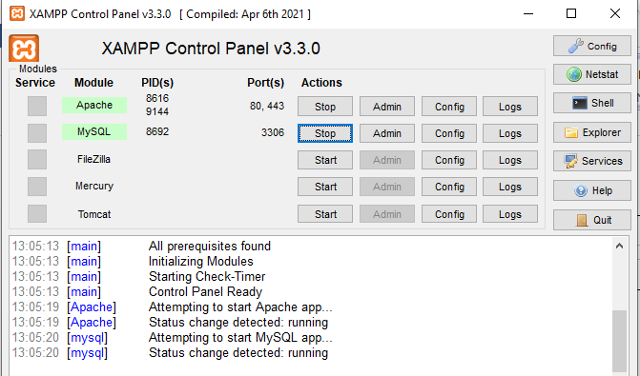

2) Insert data through form

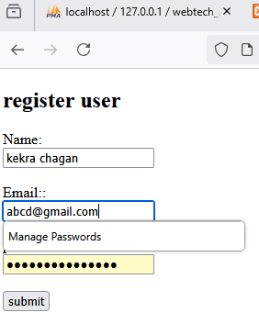

3) stored data in created detabase

